080419Android Sticky Scheduler
Use Case Diagram

Submitted to:

Prof. Ma. Rowena C. Solamo
Faculty Member
Department of Computer Science
College of Engineering
University of the Philippines, Diliman

Submitted by:
Buera, Louie
Cabiles, Miguel
Palaganas, Genesis Ian

In partial fulfillment of Academic Requirements
for the course
CS 191 Software Engineering I
of the
1st Semester, AY 2014-2015
Revision Control

History Revision:
Revision Date | Person Responsible | Version  Number | Modification
09/10/14 | Miguel Cabiles | 1.0 | Initial Document; Version number should match the one below.
09/24/14 | Miguel Cabiles | 1.1 | Revised Use-Case Model, updated descriptions.
01/28/15 | Miguel Cabiles | 2 | Revised Use-case model and descriptions. Added new use cases.

System Name: 080419Android Sticky Scheduler

Description: As the project name suggests it is a scheduler for the android platform. It aims to assists students specially in the collegiate level to manage their time. It's core features are as follows: Scheduler, Calendar integration and Location Based Functionalities.

Use-Case Diagram:

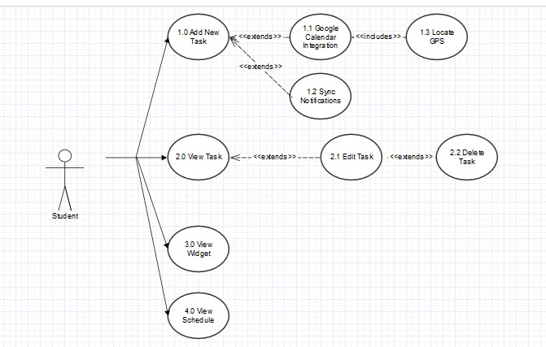

List of Actors:
Actors | Description
Student | This actor represents the user of the software. The student inputs information about the schedule, with the option of adding notes and enabling location-based alerts.

List of Use-cases:
Use-Case | Description
Use-Case 1.0 Input New Task | The user inputs information about a new task. Information includes task name, time and date when the task is due. Notes are optional.
Use-Case 1.1 Integrate into Google Calendar | The task should be synchronized into the user's Google calendar if defined.
Use-Case 1.2 Sync Notifications | The user is given the choice to input when he wants to be reminded of the task via phone notifications.
Use-Case 1.3 Locate GPS | The user is informed how much distance is between him and the task, using GPS functionalities.
Use-Case 2.0 View Task | The user may view individual tasks and information stored for that task.
Use-Case 2.1 Edit Task | While viewing a task, the user may edit the information on the task using a button.
Use-Case 2.2 Delete Task | While editing a task, the user may opt to delete the task from the application.
Use-Case 3.0 View Widget | A widget can be placed on the user's home screen showing a list of upcoming tasks.
Use-Case 4.0 View Schedule | Within the app itself, the user may view the month view of the calendar with the tasks.

